The following steps will guide you through the process of creating a method for updating the “status” on the Project Template form after a promotion is done from the Item window:

- Create a Client Side JavaScript method, named whatever you please, containing the following code:
function updateStatus()
{
var field = document.getElementById("project_state");
if (field)
{
field.innerHTML = 'Status : ' + top.aras.getItemProperty(document.item, "state");
}
}
updateStatus();
- Save your client method.
- Navigate to Administrator->Form in the TOC and open up the form for “Project Template” and lock it you can edit it.
- Click on the Form Events tab and click on Pick Related to create a new event
- Pick the method you just created. Then set the event to the “onFormPopulated” from the dropdown menu (as seen below)
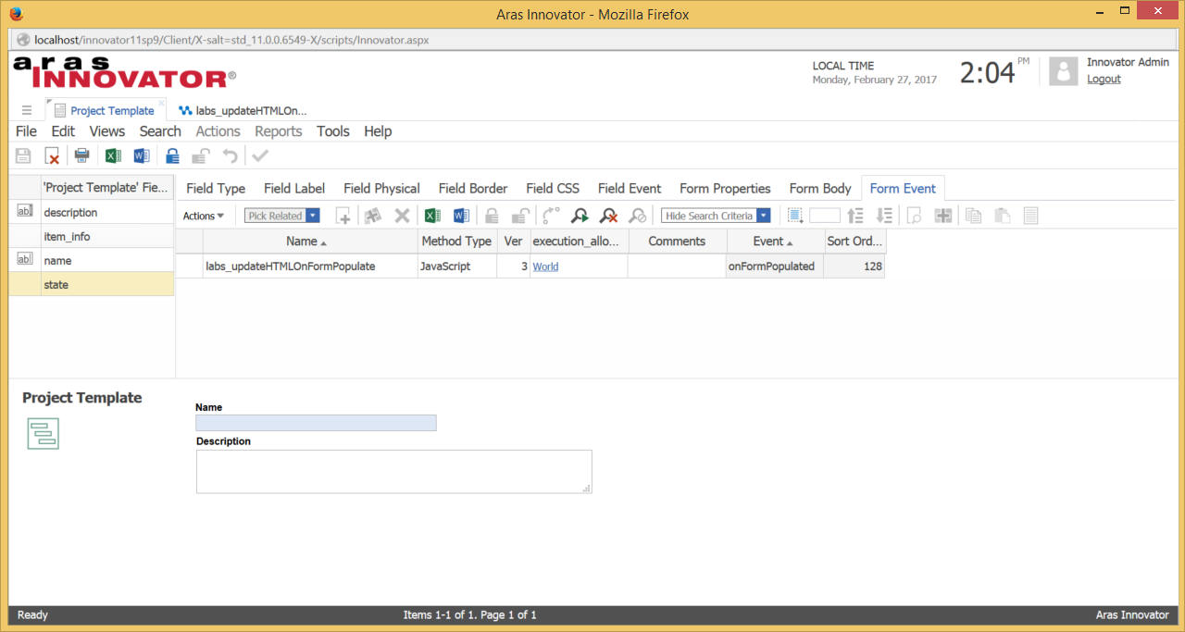
- Next you want to click on the “state” field listed under the “Project Template Field” and click on the “Field Type” tab.
- As seen in the image below, in the highlighted section, you want to add into the HTML Code in between span and style “id = project_state” (using the quotation marks).
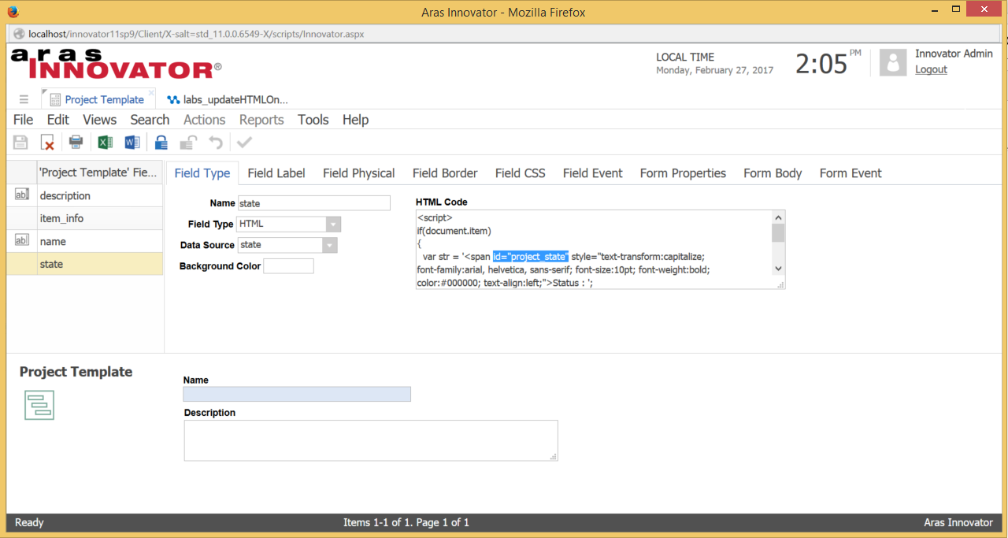

Note: This id is the id you search for in your method code in the statement:
var field = document.getElementById("project_state");
Therefore you can use whatever value for id you want as long as you make the necessary changes in the method code and in the HTML Code for the state.
- Save, unlock, and close the form.

Now you should be all set to have the status update on the form you promote the project template.

